**Review Worksheet ANSWERS – Regulation of Gas Concentration**

1: How does oxygen get from the air outside of the body to the cells?*

(3 marks)

*Air gets taken in from the environment during inspiration (0.5) and travels down through the respiratory passages to the alveoli (0.5), where it diffuses (0.5) into the capillaries surrounding the alveoli (0.5). It is then carried in the blood stream (0.5) and diffuses out of capillaries at the tissues (0.5), where it can then enter the cells (0.5).*

2: How does carbon dioxide get from the body cells to the external environment?*

(4 marks)

*Carbon Dioxide moves out of tissue cells and into the surrounding capillary network (0.5) via diffusion (0.5). It is then carried in the blood (0.5) to the lungs (0.5), where it diffuses from the capillaries (0.5) into the alveoli (0.5) and moves through the respiratory passages (0.5) to be excreted during expiration.(0.5)*

3: How is carbon dioxide transported in the blood?

(3 marks)

*As dissolved CO2 (1) and as dissolved H+ and HCO3— (1) in the blood plasma (1).*

4: What effect does increased carbon dioxide intake have on blood acidity levels and pH?

(5 marks)

*Greater intake of CO2 leads to greater concentration of CO2 (0.5), H+ and HCO3— (0.5)in the blood plasma (1). H+ is acid (1), so greater intake of CO2 leads to increased acid levels (1) and therefore decreased pH.(1)*

5: Where are the chemoreceptors for carbon dioxide concentration located? Indicate whether they respond to dissolved CO2, pH or both.

(3 marks)

|  |  |
| --- | --- |
| **Chemoreceptor Location** | **What does it respond to?** |
| *Aorta* | CO2 levels / pH levels / both |
| *Carotid artery* | CO2 levels / pH levels / both |
| *Medulla oblongata* | CO2 levels / pH levels / both |

6: Draw an annotated homeostatic feedback loop (steady state control diagram) for regulation of blood gas concentration when CO2 levels rise.

(15 marks)

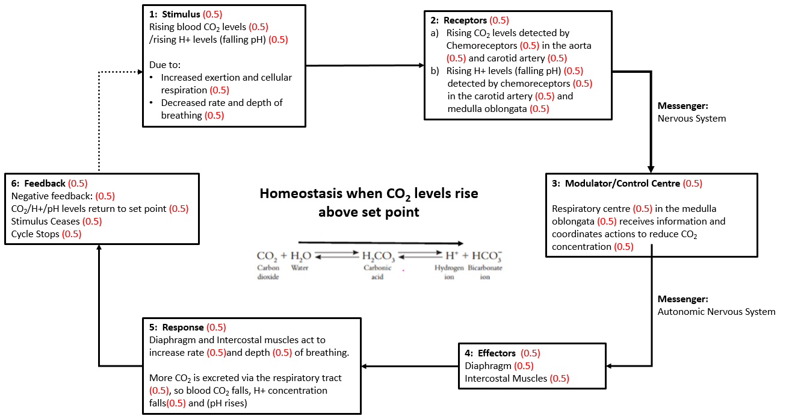

7: Draw an annotated homeostatic feedback loop (steady state control diagram) for regulation of blood gas concentration when CO2 levels fall.

(15 marks)

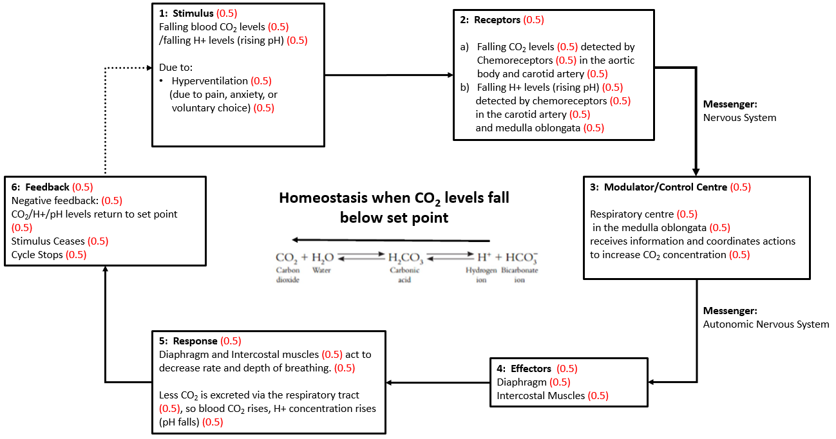

8: Describe the physiological response that occurs when O2 levels become dangerously low.

(4 marks)

*Very low O2 stimulates chemoreceptors (0.5) in the carotid (0.5) and aortic (0.5) bodies and in the medulla oblongata (0.5). Nerve impulses are transmitted to the respiratory centre (0.5) in the medulla oblongata (0.5) which stimulates the diaphragm (0.5) and intercostal muscles (0.5), increasing rate and depth of breathing (0.5).*

9: Describe the neural (nerve) pathway involved in voluntary control of breathing.

(2 marks)

*Neuron connections (0.5) from the cerebral cortex (0.5) to the spinal cord (0.5) bypass the respiratory centre (0.5) in the medulla oblongata (0.5)*

10: David, a two-year old boy, decides to hold his breath in an attempt to frighten his mother into giving him more ice cream. Should David’s mother be worried that he will die from lack of oxygen? Explain your answer. *

(10 marks of 15 possible marks)

*In this situation, David’s mother should not be worried (1). If the breath is voluntarily held for a long period of time (1), CO2 levels in the blood rise (1), causing the blood to become more acidic (1), and stimulating chemoreceptors (1) in the medulla oblongata (0.5) and carotid artery (0.5). This causes an overwhelming urge to breathe (1). Even if David is able to overcome the urge to breathe (1), falling O2 levels (1) would eventually cause unconsciousness (1), at which point the respiratory centre (1) in the medulla oblongata (1) would regain involuntary control (1) of rate and depth of respiration (1) and David would start breathing again (1).*

11: Kim and Meredith are having a competition to see who can hold their breath under water for the longest. They decide to float face-down near the shallow end of the pool and hold their breath for as long as possible, then stand up when they need to breathe. Before they begin, Kim breathes very rapidly for 30 seconds, and then both Kim and Meredith float face down. After a while, Meredith surfaces and realises she has lost the competition. After a moment, she realises Kim is unconscious. Meredith pulls Kim out of the pool, calls an ambulance on her phone and starts CPR. Thankfully, Kim is able to start breathing again and recovers in hospital.   
  
Using your understanding of homeostatic control of blood gas concentration, explain what happened to Kim. *

(10 marks)  
  
*Kim hyperventilates prior to swimming (0.5). This causes her to excrete more CO2 (0.5), leading to a drop in concentration of dissolved CO2 (0.5)* *and therefore H+ (0.5) in her blood (0.5), because CO2 is transported in the blood as H+ and HCO3-- (1)*. *As a result, her blood pH rises (0.5). When she holds her breath and begins to float face down, her O2 levels begin to fall (0.5), and her CO2 levels begin to rise (0.5). Because she hyperventilated (0.5), she has started with lower levels of CO2,(0.5) so it takes longer for levels of CO2 and hydrogen ions to rise to the threshold (0.5) where there is an overwhelming urge to breathe (0.5). Meanwhile, her oxygen levels continue to fall (0.5), and eventually get low enough that she loses consciousness (0.5) face down in the water (0.5), before her carbon dioxide levels trigger breathing (0.5). This is called shallow water blackout (0.5). She will start breathing again once her CO2 levels rise (0.5), but if she is still face down in the water, she will inhale water and drown.(0.5)*

12. Which part of the peripheral nervous system matches each of the following descriptions?

(6 marks)

|  |  |
| --- | --- |
| **Description** | **Part of the Peripheral NS** |
| Cell body located in the dorsal root ganglion of the spinal cord | *Sensory* |
| Cell body in the spinal cord, synapse in the chain ganglia near spinal cord, second unmyelinated neuron to effector. | *Sympathetic (autonomic motor)* |
| Releases Noradrenalin at the effector tissue | *Sympathetic (autonomic motor)* |
| Exits spinal cord at ventral root ganglion, synapse in ganglia close to the target organ. | *Parasympathetic (autonomic motor)* |
| Cell body in spinal cord, myelinated axon extends to target tissue. No additional synapses. | *Somatic Motor* |
| Under voluntary control | *Somatic Motor* |